Docker Task -3

Task Description:

Create a custom docker image for nginx and deploy it using docker compose, where the volume bind mount should be at /var/opt/nginx location. Push the created custom docker image to your docker-hub.
EC2 Has been launched
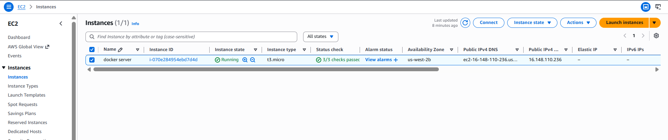
Docker Installed
Docker Compose Installed
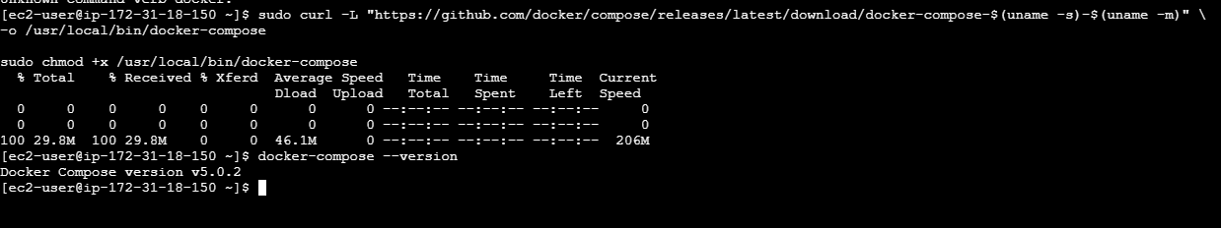
volume bind mount /var/opt/nginx
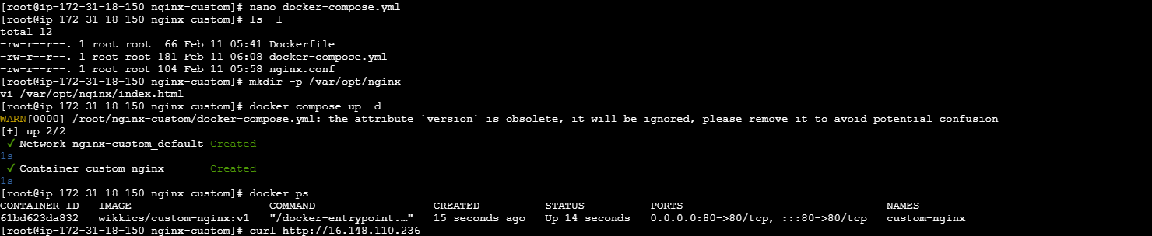
Created a docker file ,Nginx Configuration .
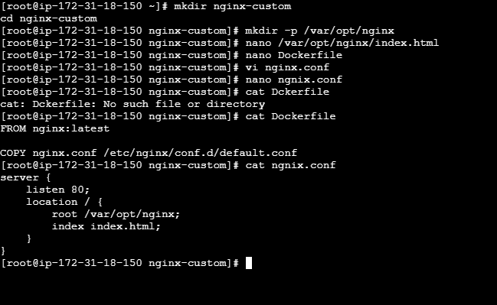
Image Build
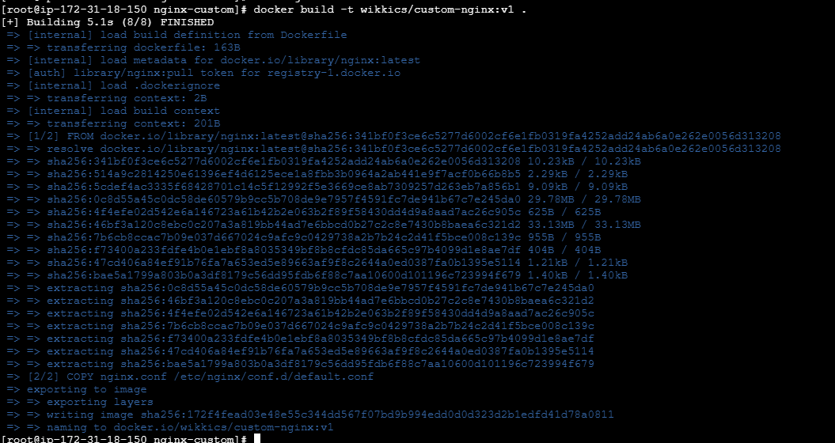

Image Pushed to docker hub:
